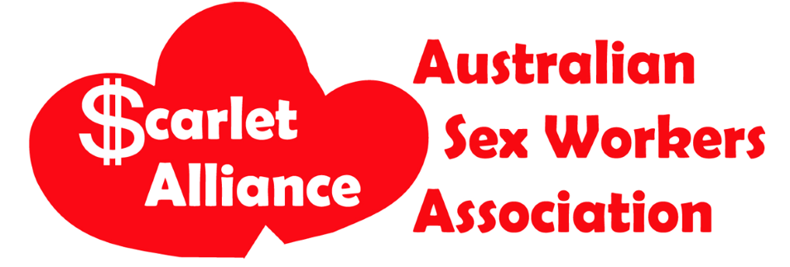APPLICATION FORM: Vixen Male Project Worker, 2 days per week, Brunswick
Phone
–
02
9517
2577
Post
–
PO
Box
854
Newtown
NSW
2042
Head
Office
–203/1
Erskineville
Road
Newtown
NSW
2042
Email
–
info@scarletalliance.org.au
Web
–
www.scarletalliance.org.au
ABN
–
86
612
112
065
|
ARBN
–
149
618
137
Please answer the following. Each answer should be no more than 500 words (around 2-3 paragraphs).
Name:_______________ ____

- Please tell us about your experience as a male sex worker.
- What are some current issues for male sex workers in Victoria?
- Why do you want to work at Vixen?
- What do you know about the sex worker rights movement in Victoria and/or Australia and/or internationally?
- What are some strategies you would use to connect with male sex workers, including those who have a different working experience to your own?
- What is your understanding of sex workers sharing information and knowledge with each other (e.g. health promotion, peer education, harm reduction, community development and HIV prevention)?
- This position will include connecting and working with sex workers and other people from different backgrounds and experiences, such as migrants, people living with HIV/BBVs, people with experience of incarceration, people who inject drugs, and trans people. How will you ensure your work and communication does not stigmatise or alienate people from these communities?
- Vixen uses Google Workspace, including Gmail, Google Calendar, Google Drive - tell us your level of familiarity with them and how you would develop your skills in using them if needed.
- Part of this job involves driving to workplaces and meeting with sex workers. Do you have a current full driver license?
- What other skills and experience do you have that are relevant to this position?

